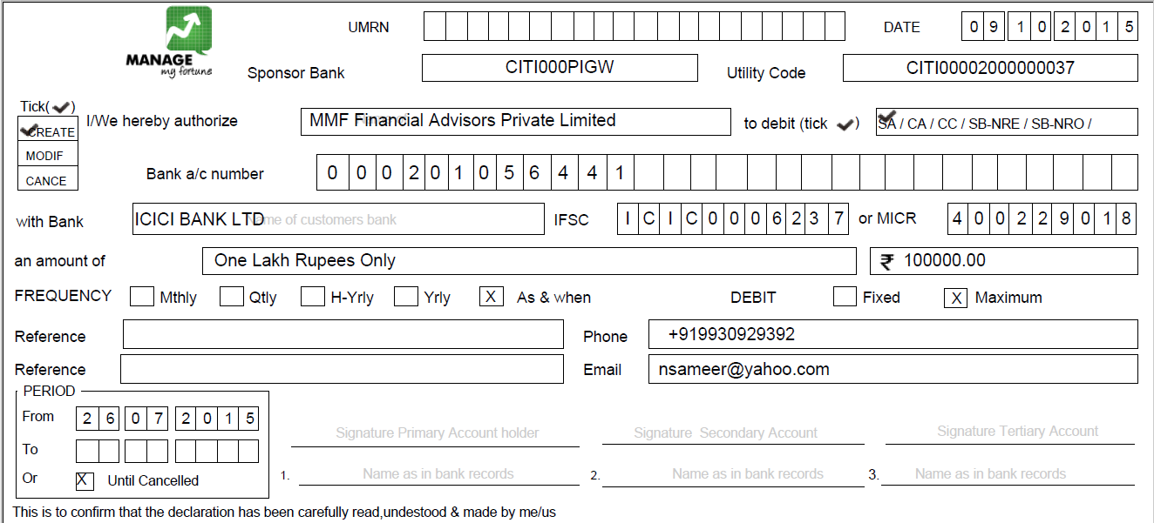

15. IFSC

14. MICR

13.Account No

12.A/c Type

11.Bank Name

7.End Date

6.Start Date

5.Frequency

4.Amount

3.Debit Type